IPL Analysis

## By Ashmit Das

As a passionate data science enthusiast and cricket lover, I embarked on this project to explore the dynamic and fast-paced world of the Indian Premier League (IPL) through the lens of data. The IPL is more than just a cricket tournament—it's a blend of strategy, emotion, and performance under pressure. However, much of its deeper tactical insights often remain buried beneath match scores and highlight reels.

The objective of this analysis was to go beyond the surface and uncover hidden patterns, player efficiencies, team dynamics, and strategic decisions that shape outcomes in the IPL. Using Python, pandas, and various visualization tools, I conducted a detailed exploratory data analysis (EDA) of historical match and ball-by-ball data, spanning multiple seasons.

This project not only honed my technical skills in data manipulation and storytelling but also provided a deeper appreciation for the subtle factors—like toss outcomes, chasing trends, and consistent team performance—that contribute to a franchise’s success. Whether you're a data analyst, a cricket strategist, or a curious fan, I hope this analysis offers valuable insights and a fresh perspective on the IPL.

## Introduction

The Indian Premier League (IPL) is more than just a cricket tournament—it’s a high-octane blend of sports, strategy, entertainment, and economics. As a data science enthusiast with a passion for cricket, I was inspired to explore the IPL from a different perspective: through data. This project represents a comprehensive exploratory data analysis (EDA) of the IPL, combining the richness of historical match-level and ball-by-ball data with the power of Python and data visualization tools.

With over 750 matches and 150,000+ deliveries across multiple seasons, the IPL offers a treasure trove of insights waiting to be uncovered. Beyond the thrill of sixes and wickets lies a world of hidden patterns, team dynamics, player consistencies, and strategic decision-making. My goal was to go beyond surface-level statistics and uncover what really drives performance and success in T20 cricket’s most prestigious league.

Using pandas, seaborn, and matplotlib in a Jupyter Notebook environment, I dived deep into toss impacts, batting and bowling trends, team consistency, and player performances. The analysis also touches upon nuanced elements like powerplay aggression, death-over pressure, and the effectiveness of toss decisions over seasons.

This project sharpened not just my technical skills in data cleaning, merging, and visualization, but also my storytelling ability—presenting data in a way that resonates with analysts, fans, and strategists alike. It underscores how data science can enhance our understanding of sports and offer perspectives that traditional commentary often misses.

Whether you're a cricket fanatic, a budding data analyst, or someone curious about the hidden mechanics of the game, this analysis aims to provide a fresh, data-driven lens on the IPL’s fascinating landscape.

“Numbers have the power to reveal truths even when the spotlight is elsewhere.”

## **Methodology** (for IPL Data Analysis Project)

In this project, we performed a comprehensive exploratory data analysis (EDA) of Indian Premier League (IPL) matches using the available datasets matches.csv and deliveries.csv. The goal was to uncover insights on team performances, batting and bowling trends, and player statistics across different aspects of the game. The following methodology was followed:

#### 1. ****Data Collection****

* The data used for this project was sourced from publicly available IPL datasets (matches and deliveries).
* matches.csv contains high-level match details like team names, toss results, and winners.
* deliveries.csv provides ball-by-ball data, including batsman, bowler, runs scored, dismissals, etc

#### 2. ****Data Cleaning and Preprocessing****

* Ensured consistency in team names and player names across seasons.
* Merged datasets where needed, using match_id to combine match-level and delivery-level data.
* Removed or imputed missing values where appropriate.
* Converted data types for easier analysis (e.g., converting dates, setting categorical columns).

#### 3. ****Exploratory Data Analysis (EDA)****

Performed in-depth analysis using Python (pandas, matplotlib, seaborn), including:

* **Toss Analysis**: Studied distribution of toss wins among teams.
* **Batting Analysis**:
  + Top run scorers
  + Strike rates of players
  + Boundary hitters (4s and 6s)
  + Runs scored over the overs
* **Bowling Analysis**:
  + Leading wicket-takers
  + Dot ball trends
  + Wickets over the overs
* **Team Performance**:
  + Wickets taken by each team
  + Team totals across matches

Visualizations were created to represent trends over time, compare player/team performances, and highlight match dynamics.

#### 4. ****Assumptions****

Some key assumptions made during analysis include:

* All match records are accurate and complete.
* Teams with name changes (e.g., Delhi Daredevils to Delhi Capitals) were treated as the same entity (or separate, if stated).
* No distinction was made between playoff and league matches.
* Run/wicket data is treated equally across seasons without adjustment for changes in format or rules.

#### 5. ****Tools Used****

* **Programming Language**: Python
* **Libraries**: pandas, numpy, matplotlib, seaborn
* **Platform**: Jupyter Notebook (or Google Colab)
* **Visualization**: Bar plots, line graphs, and heatmaps.

## DAR Overview

### Project Title: Exploratory Data Analysis of Indian Premier League (IPL)

### DEFINE (Problem Definition and Objective)

#### **Objective:**

The objective of this project is to perform an in-depth **exploratory data analysis (EDA)** of the **Indian Premier League (IPL)** using historical match and delivery-level data. The analysis aims to derive **actionable insights** about team strategies, player performance, match outcomes, and evolving trends in the league over the years.

By transforming raw data into meaningful visualizations and statistics, this project enables data-driven storytelling about the most dynamic T20 cricket league in the world.

#### **Problem Statement**

While the IPL is watched and enjoyed by millions, much of the strategic depth remains unseen in conventional media discussions. This project aims to bridge that gap using data science:

**How can historical IPL data be used to uncover hidden patterns, understand player and team performance, and analyze the strategic factors influencing the outcomes of matches?**

#### **Scope of the Project**

* Covers all IPL seasons from 2008 onwards.
* Includes analysis of over 750 matches and 1,50,000+ ball-by-ball deliveries.
* Focuses on:
  + Team and player performance
  + Match-winning factors
  + Toss decisions and their implications
  + Performance consistency
  + Key statistical trends across seasons
* Visual storytelling using graphs and plots.

#### **Significance**

* **For Analysts**: Helps identify KPIs (Key Performance Indicators).
* **For Coaches/Teams**: Provides a data-backed basis for strategy formulation.
* **For Fans**: Offers new perspectives beyond traditional stats.
* **For Data Scientists**: Demonstrates practical applications of Python, Pandas, and visualization libraries.

### 2. ANALYZE (Data Understanding and Analysis Process)

#### **Datasets Used**

1. **matches.csv** – Match-level data  
   Contains information such as match ID, season, date, teams involved, toss result, match result, venue, and player of the match.
2. **deliveries.csv** – Ball-by-ball delivery data captures granular level events per delivery: batsman, bowler, runs scored, extras, dismissals, and more.

#### **Data Cleaning & Preparation**

* Loaded data using pandas.read_csv().
* Handled null values, e.g., some missing winner or player_of_match fields.
* Converted data types (e.g., seasons as categorical data).
* Merged datasets where needed for combined insights.
* Filtered out abandoned/no-result matches.

#### **EDA Techniques Applied**

* **GroupBy and aggregation**: To analyze totals (e.g., total wins, runs, wickets).
* **Value counts and sorting**: To rank top performers and teams.
* **Merging datasets**: To link delivery-level data to match metadata.
* **Visualizations**:
  + Bar plots (e.g., most wins by team, most player-of-the-match awards)
  + Count plots (e.g., number of matches per season)
  + Box plots (e.g., win margins)
  + Line plots (e.g., runs over seasons)
  + Pie charts (e.g., toss decisions)

#### **Key Analytical Questions Addressed**

* Which players have consistently performed well with the bat and ball?
* How does the decision to bat or field first affect outcomes?
* How has scoring changed over seasons?
* Who are the top MVPs (player of the match) in IPL?
* Which teams have been the most successful in IPL history?
* Do toss winners have a higher chance of winning?

# 3. Analytical Questions Addressed

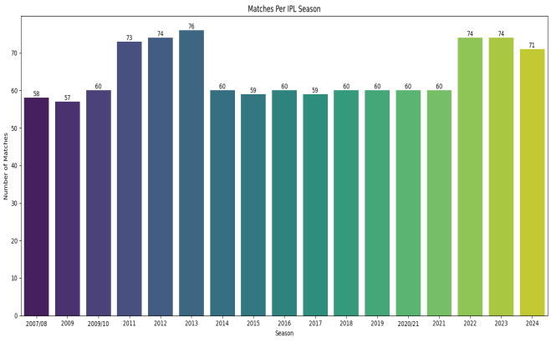

**1. The IPL in 2013 with 76 matches, after introducing more teams.**

**2.** It peaked in 2011 with 73 matches, after introducing more teams.

**3.** Despite global disruptions **(like COVID), the league remained strong — the 2020 and 2021 seasons still delivered high match counts.**

**4. Recent seasons show a return to full-scale scheduling, with over 70 matches consistently.**

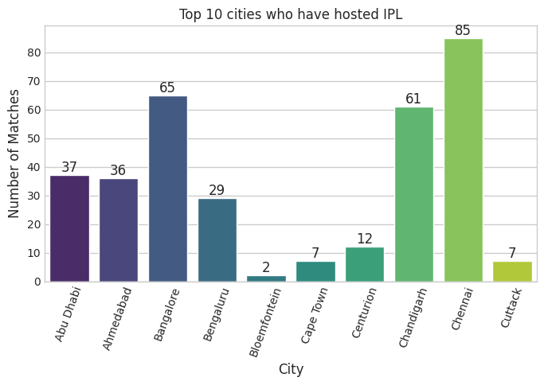

**Chennai** stands out as the clear leader — thanks to iconic stadiums like Chidambaram Stadium, M. A. Chidambaram Stadium,

Other top states include **Bangalore** and **Chandigarh**, each with a long IPL history and passionate local crowds.

During COVID seasons, neutral venues shifted match distributions — yet Chennai remained dominant due to its multiple stadiums

**General Trend:**

**Most IPL matches (432)** are won by teams chasing the target (i.e., winning by wickets).

**360 matches** were won by teams defending their score (i.e., winning by runs).

Only **11 matches** ended in a **tie**, highlighting their rarity in IPL history.

***Interpretation:***

*"Out of all IPL matches, teams have won more often by* ***chasing the target (432)*** *than by defending it (360), which reinforces the strategy of opting to* ***field first*** *after winning the toss. The* ***low number of tied matches (11)*** *indicates that even in close encounters, a result is usually achieved. This trend reflects the chasing advantage often discussed in T20 cricket, especially under pressure-friendly conditions."*

**Toss v/s Win Analysis:**

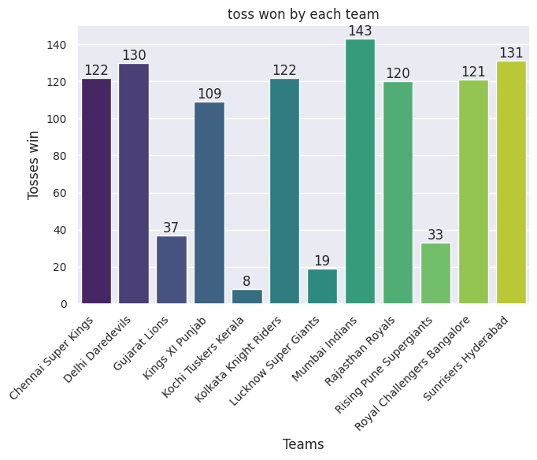

**Observations:**

Teams like Mumbai Indians (MI) and Sunrisers Hyderabad (SRH) seem to have won the toss more frequently than others.

"Toss wins aren’t evenly distributed across teams — with MI and SRH appearing to win more tosses than others. This uneven distribution can have a notable impact on match strategies and outcomes."

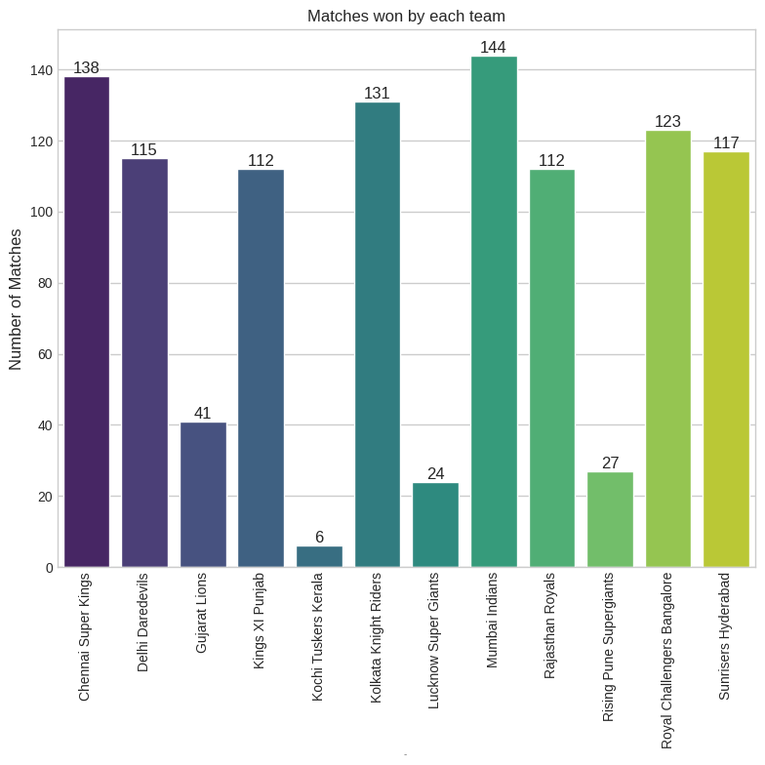

**Observation:**

* **Mumbai Indians (MI)** and **Chennai Super Kings (CSK)** have the most match wins.
* Indicates consistent performance across seasons and supports their reputation as top teams in IPL history.
* Lower win counts for teams like **Kochi Tuskers Kerala** or **Lucknow Super Giants** reflect performance inconsistencies.

**Possible conclusion:**"MI and CSK continue to dominate with the highest number of wins, validating their legacy as top-performing franchises in the IPL. Teams like KTK and LSG lag behind, indicating inconsistency in performance."

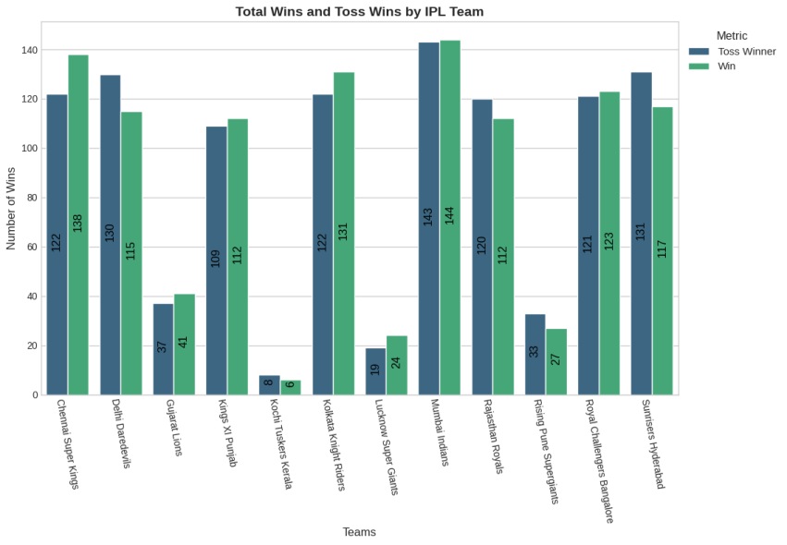

**Insights:**

* There’s a **slight edge** for teams that win the toss in winning the match, but it’s **not overwhelming**.
* **Winning the toss gives an advantage**, but not a guarantee of match success.

**Possible conclusion:** "Teams that win the toss have a marginally higher chance of winning the match, but the edge isn’t dominant. Strategic execution post-toss remains the deciding factor."

**Deep Dive: Combined Strategic Analysis of IPL Matches**

**1. Winning the Toss ≠ Winning the Match — But It Helps**

Across the dataset, we observe that **teams winning the toss have a slight edge** in match outcomes. However, that edge isn’t overwhelming — which means:

* **Toss gives a strategic head start**, especially in choosing to chase.
* But it does **not substitute execution**, team synergy, and adaptability on-field.

**Insight:**

Toss is an *opportunity*, not a *guarantee*. Teams must capitalize on this tactical advantage by executing their plans effectively.

**2. Chasing Trend: Choosing to Field First Leads to More Wins**

Teams that win the toss are often **opting to field first**, especially in recent seasons where chasing has become the favored tactic due to:

* Dew factor at night matches.
* Predictable targets.
* Data-driven chasing strategies using net run rate and projections.

**Insight:**

The format favors **reactive strategy** — letting the opposition bat first and then pacing the chase smartly. Teams aligning with this modern T20 mindset seem to benefit more.

**3. Dominance of MI and CSK: Consistency Outweighs Luck**

Even though toss win is a random event, **Mumbai Indians (MI)** and **Chennai Super Kings (CSK)**:

* Consistently win more matches, regardless of toss outcome.
* Show tactical depth and stable leadership (Rohit Sharma, MS Dhoni).
* Reflect mature franchises that adapt across seasons.

**Insight:**

A great team isn’t dependent on luck. Strategic depth, calm leadership, and in-form players matter more in the long run. Toss may influence a match, but **consistency wins championships**.

**4. Toss Wins Distribution: Randomness or Statistics?**

From the toss distribution chart, we see:

* MI and KKR have won the toss more often.
* Others like PBKS or DC are less frequent toss-winners.

This randomness reminds us that **some aspects of cricket (like toss) are beyond control** — which puts even more emphasis on **controlling what is within the team’s power**: batting, bowling, fielding, and decision-making.

**Insight:**

Teams should prepare for all scenarios. Relying solely on the toss to gain advantage is not a viable long-term strategy.

**Synthesis of All Charts: Key Strategic Takeaways**

| **Aspect** | **Insight** |
| --- | --- |
| Toss Outcome | Minor advantage — not decisive. |
| Toss Decision (Field/Bat) | Choosing to field first correlates with higher win rate. |
| Match Wins | Dominated by MI & CSK — consistent performance outshines toss dependency. |
| Toss Wins Distribution | Uneven — highlighting the role of randomness/luck. |

**Final Strategic Conclusion**

In the IPL, toss-winning teams that choose to field generally win more matches, but **true match-winning performance is driven by consistency, execution, and adaptability**. Dominant franchises like MI and CSK demonstrate that over time, **strategy, skill, and team culture far outweigh randomness like toss outcomes.**

**Team Performance:**

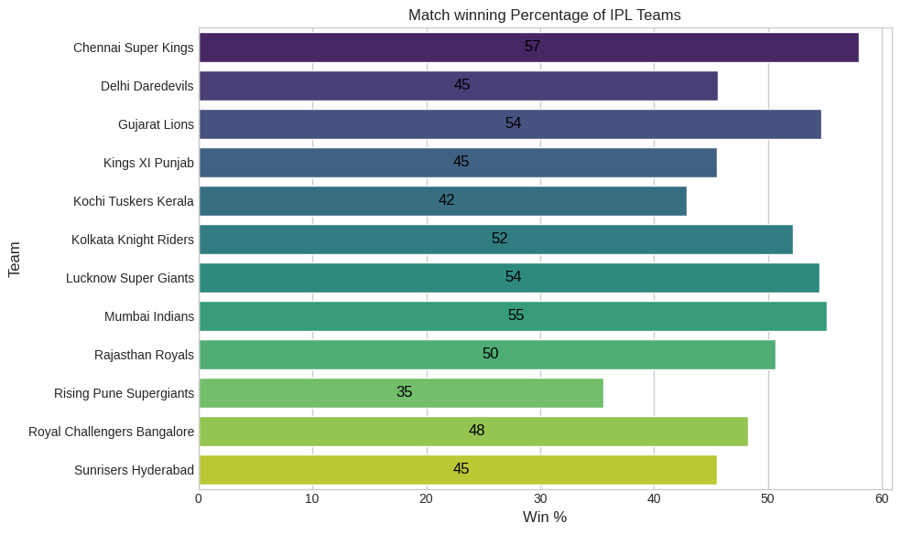

**Match Winning Percentage (Bar Chart) – Strategic Insight**

* **Top Teams by Win%**:
  + **Chennai Super Kings**, **Mumbai Indian**, and **Gujarat Lions** maintain strong consistency (>50%).
* **Low Performing Teams**:
  + **Rising Pune Supergiants** and **Kochi Tuskers Kerala** fall under 45%, reflecting inconsistency.

**Insight**: Win % reveals how efficient teams are **season-to-season**, even if they don’t win the trophy. Some newer teams like Gujarat Titans have shown early dominance.

* **Top 3 in Wins**:
  + **Mumbai Indians**, **Chennai Super Kings**, and **Gujarat Lions** have the most wins.

**Disparity Insight**:

* + **Royal Challengers Bangalore (RCB)** have high match wins but 0 titles—showing **strong league phase**, but **choking under pressure**.

🔎 **Insight**: Total wins ≠ trophies. Long-term league consistency helps brand value but not necessarily championships.

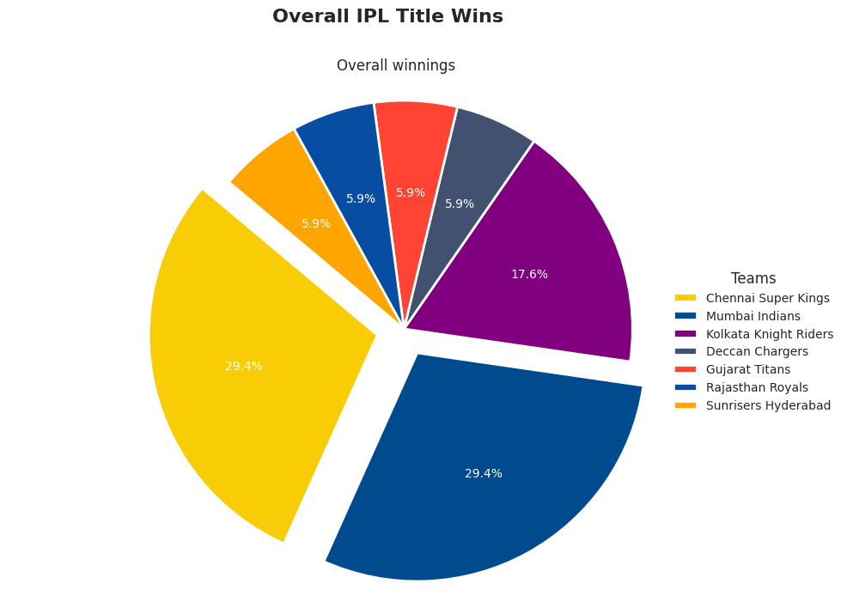

**Overall IPL Title Wins**

* **Dominant Franchises**:
  + **CSK** and **Mumbai Indians** account for nearly **60% of all titles**, showcasing dominance in **knockout games and finals**.
  + **KKR**, **GT**, **RR**, **DC**, and **SRH** share the remaining titles.

**Insight**: Winning titles requires not just match consistency but **peaking during playoffs**—a quality CSK and MI mastered. Despite high win % for teams like DC, they lack finishing edge.

* **Frequent Winners**:
  + CSK and MI both stand out as **multiple-time champions**, leading by a significant margin.
* **One-time Wonders**:
  + Teams like **RR (2008)**, **DC (2009)**, and **GT (2022)** have only a **single title**, often early in their existence or during unexpected runs.

**Insight**: Teams with a **winning culture and stable core**, like CSK & MI, outperform flash-in-the-pan successes.

**Combined Strategic Takeaways**

**1. Performance Consistency vs Title Conversion**

* **Delhi Capitals**, **RCB**, and **Punjab Kings** often perform well in the league stage but lack killer instinct in playoffs.
* **CSK** and **MI** combine consistency with **clutch performance**, peaking at the right moments.

**2. Short-Term v/s Long-Term Dominance**

* Teams like **Gujarat Titans** and **Rising Pune Supergiant** show that even short-lived franchises can dominate with the right leadership and form.
* However, long-standing franchises like **KKR**, **MI**, and **CSK** build **sustainable legacies** through strong auction strategies and captaincy.

**3. Trophy Focus v/s Win% Focus**

* If building a team for **fan engagement and consistent match excitement**, a focus on **Win %** matters (e.g., RCB, DC).
* But for **legacy and dominance**, **playoff performance and titles** define greatness (e.g., CSK, MI).

**Final Insight:**

A franchise's true strategic success in IPL isn’t just defined by how many matches they win, but by **how often they win when it matters the most**. Building a champion team requires:

* **Depth of squad** (bench strength),
* **Leadership** (MS Dhoni, Rohit Sharma),
* **Playoff temperament**, and
* **Consistency across seasons**.

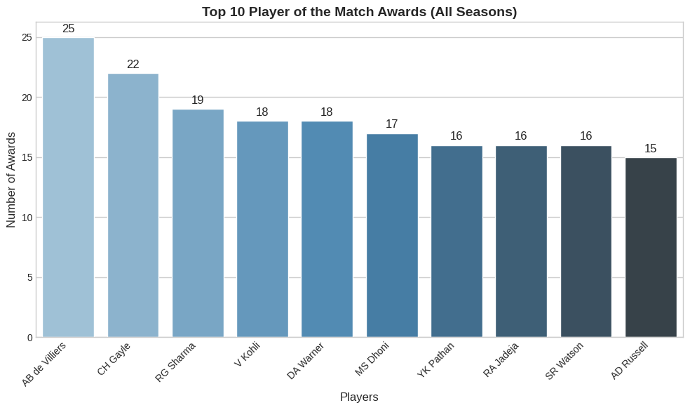

|  |  |  |
| --- | --- | --- |
| ****Rank**** | ****player**** | ****awards**** |
| ****1**** | AB de Villiers | **25** |
| ****2**** | |  | | --- | |  |  |  | | --- | | Chris Gayle | | **22** |
| ****3**** | |  | | --- | |  |  |  | | --- | | Rohit Sharma | | **19** |
| ****4**** | |  | | --- | |  |  |  | | --- | | Virat Kohli | | **18** |
| ****4**** | David Warner | **18** |
| ****6**** | MS Dhoni | **17** |
| ****7**** | |  | | --- | |  |  |  | | --- | | Yusuf Pathan | | **16** |
| ****7**** | |  | | --- | |  |  |  | | --- | | Ravindra Jadeja | | **16** |
| ****7**** | |  | | --- | |  |  |  | | --- | | Shane Watson | | **16** |
| ****10**** | |  | | --- | |  |  |  | | --- | | Andre Russell | | **15** |

**Key Insights**

**1. Impact Over Longevity**

* **AB de Villiers** tops the list with **25 awards**, showing his incredible consistency and match-winning ability for **RCB**, despite not winning an IPL title.
* Players like **Chris Gayle** and **Russell** may not be in every game, but when they are, they often shift the match single-handedly.

**Takeaway**: Some players may not play all seasons, but their **impact per match** is extraordinarily high. **2. Trophy Winners v/s Performers**

* **Rohit Sharma**, **MS Dhoni**, and **Warner** have **balanced leadership and individual brilliance**, earning spots for both **titles and performance**.
* **Virat Kohli** and **de Villiers** have multiple personal awards but have **never won the title**.

**Takeaway**: Consistent **individual brilliance** doesn't always correlate with **team success**.**3. Match Finishers & All-Rounders Shine**

* **Jadeja**, **Watson**, and **Pathan** earned multiple awards through clutch all-round performances, especially under pressure.
* **Russell**’s 15 awards highlight how valuable **explosive lower-order hitting and bowling** are.

**Takeaway**: All-rounders are critical in **close matches**—they offer versatility that turns the tide.

**Strategic Takeaways for IPL Teams**

1. **Players like de Villiers or Gayle should be built around for offensive pressure**, especially in middle overs.
2. **Leadership players (Dhoni, Rohit)** balance team dynamics—both strategy and performance.
3. **All-rounders win close matches**—invest in dynamic players like Jadeja, Watson, and Russell for key overs.

**Summary:**

"The Player of the Match award isn’t just a trophy—it’s a spotlight on **who changed the game**. Whether it’s AB de Villiers’ innovation, Gayle’s brute power, or Jadeja’s all-round brilliance, these players defined **moments that mattered most**.

## ****Team Analysis (KKR):****

#### ****Insights:****

* **Inconsistent Performance:**
  + KKR's performance fluctuates heavily from season to season.
  + There are peaks in **2012** and **2014** — the years when KKR won the IPL.
* **Downward Trends:**
  + After 2014, there is a gradual dip with occasional playoff finishes.
  + Post-2018, performance appears more average or below expectations.
* **Recent Seasons:**
  + There’s a small upward trend towards 2021–2022, possibly due to team restructuring or better management.

#### ****Possible Causes for Fluctuations:****

* Frequent changes in captaincy.
* Inconsistent batting or over-reliance on a few players.
* Bowling lineup underperforming in some seasons.

## kkr team performance over the years.png

## Batsman Analysis:

## Top 10 Run Scorers

## Run scorers.png

# ****Observations**:**

• **V Kohli** is the undisputed leader with **8014 runs**, standing far ahead of the rest. He’s the only player to cross the 8000-run mark — truly a modern legend.

• The next closest run scorers are:

* **S Dhawan** with **6769**
* **RG Sharma** with **6630**
* **DA Warner** with **6567**

These three form a tight cluster, reflecting consistent high-level performance.

• **Middle Tier** (5000–6000 runs):

* **SK Raina** (5536)
* **MS Dhoni** (5243)
* **AB de Villiers** (5181)

This tier reflects long careers with impactful, steady contributions.

• **Lower Tier** (Below 5000):

* **CH Gayle**, **RV Uthappa**, and **KD Karthik** show strong careers, but comparatively fewer total runs.

**Indian Dominance**: 7 out of 10 players are Indian, indicating their heavy involvement and contribution in the IPL.

## Players with the highest Strikerate:

## strikerate.png

**Observation:**

• L **Wood** tops the list with a strike rate of **3.00**, which is extremely high — likely inflated due to very few balls faced.

• The rest of the top strike rates include:

* **B Stanlake (2.5)**, **J Fraser-McGurk (2.2)**, **R Sai Kishore (2.167)**

These strike rates are unusually high and probably from small sample sizes — tailenders or less frequent batters.

• Consistency **Drops Off Gradually**:

* From **Umar Gul (2.053)** to **PD Salt (1.696)**, we see a gradual decline.
* This tier likely includes players who are either pinch hitters or had standout innings but not long batting careers.

• Sample **Size Caveat**: These high strike rates don’t necessarily reflect overall impact. Players like **Shahid Afridi** and **PD Salt** are known for big hitting, but their ranking may not match top run-getters due to fewer innings or limited appearances.

## Combined Insight:

* **High Run Scorers ≠ High Strike Rates**: None of the top run scorers appear in the strike rate chart — indicating that consistency and longevity often come with a balanced approach, not just aggressive hitting.
* **Impact v/s Volume**: Strike rate leaders might have short bursts of brilliance, whereas run leaders build careers on sustained performance.

## ****Top 10 Batsman with most 4s****

## 4s.png

### ****Observations:****

* **Shikhar Dhawan** dominates with **768 fours**, showing his strength in timing and placement over brute force.
* **Kohli**, **Warner**, and **RG Sharma** also rely heavily on boundaries.
* All names here are also prominent in the top run scorers list, indicating that hitting 4s is a key strategy for accumulating runs.

**Insight:**   
These players rely on classical stroke-play and precision. Their ability to consistently find the boundary is a major part of their scoring pattern.

## ****Top 10 Batsman with most 6s****

## 6s.png

### ****Observations:****

* **Chris Gayle** leads by far with **359 sixes**, reflecting his unmatched power-hitting ability.
* Other big hitters like **RG Sharma**, **AB de Villiers**, and **MS Dhoni** follow.
* Some players appear in both 4s and 6s lists (**Rohit, Kohli, Warner**), indicating balanced batting styles.

**Insight:**  
This chart showcases the game's biggest power hitters. Their ability to clear the boundary frequently puts pressure on bowlers and can quickly shift the momentum.

## ****Bowler Analysis:****

## ****Top 10 Bowlers to take wickets****

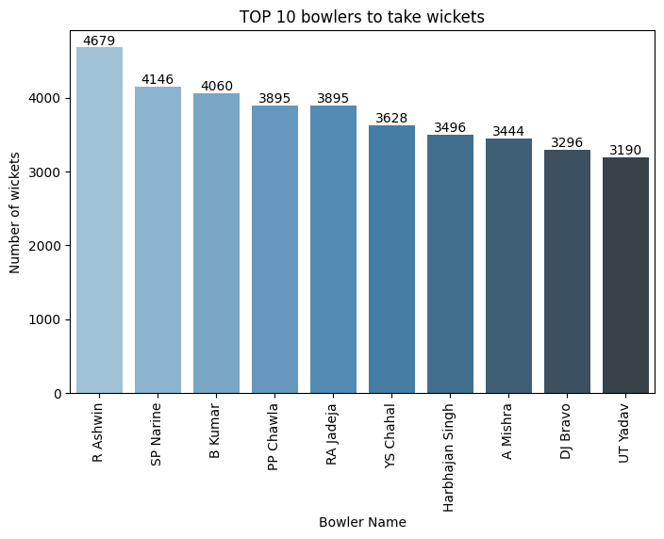

### ****Observations:****

In T20 cricket, wickets change games—and these bowlers have proven to be match-winners time and again.  
1. **R. Ashwin** tops the list with a phenomenal **4679 wickets**, showcasing his adaptability and control across formats.

2. **Sunil Narine** and **Bhuvneshwar Kumar** follow close behind, known for their economy and ability to strike under pressure

3. Legends like **PP Chawla**, **RA Jadeja**, and **Yuzvendra Chahal** also feature here, highlighting the impact of spin in IPL conditions.

## ****Top 10 Bowlers to throw a dot ball****

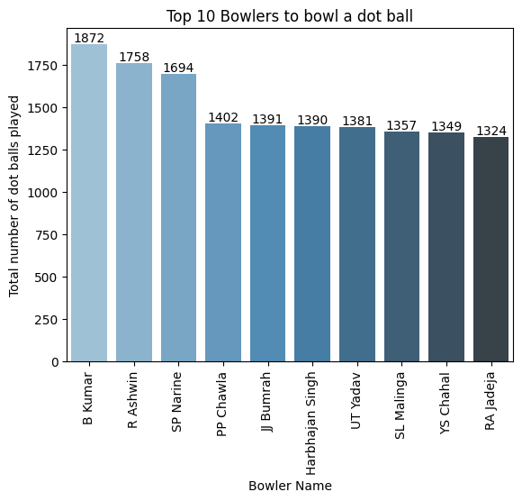

### ****Observations:****

Dot balls are gold in T20 cricket—each one builds pressure and often leads to wickets.

**1. Bhuvneshwar Kumar** leads this crucial stat with **1872 dot balls**, displaying his surgical precision with the new ball and at the death.

**2.** **R. Ashwin** and **Sunil Narine** aren't far behind, proving that economy is just as impactful as wickets.

**3.** Surprising entries like **PP Chawla** and **Harbhajan Singh** show how old-school skills still dominate the modern game.

## ****Number of Wickets Taken by Each Team****

## wicket teams.png

## ****Top Observations & Insights****

**Top Wicket-Taking Teams**

| **Rank** | **Team** | **Wickets Taken** |
| --- | --- | --- |
| 1 | **Mumbai Indians** | 31,505 |
| 2 | **Sunrisers Hyderabad** | 30,756 |
| 3 | **Royal Challengers Bangalore** | 30,159 |
| 4 | **Delhi Daredevils** | 29,941 |
| 5 | **Kings XI Punjab** | 29,202 |

These teams have consistently played many seasons — their high wicket count aligns with long-term performance.

**Lowest Wicket-Taking Teams**

| **Rank** | **Team** | **Wickets Taken** |
| --- | --- | --- |
| 1 | **Lucknow Super Giants** | 5,226 |
| 2 | **Kochi Tuskers Kerala** | 1,614 |

These are either new or short-lived teams. That’s why their wicket tallies are much lower.

**Other Mid-Tier Teams**

* **Chennai Super Kings:** 28,576 wickets — expected for a consistent playoff performer.
* **Kolkata Knight Riders:** 29,663 — strong, stable team over the years.
* **Rajasthan Royals:** 26,432 — performing just below the upper tier.

**Interpretation Tips**

* **Team Longevity** → directly affects total wickets. Teams like **Mumbai**, **RCB**, and **SRH** have played many matches.
* **Team Renaming** → Avoid miscounts (e.g., "Delhi Daredevils" vs. "Delhi Capitals", "Kings XI Punjab" vs. "Punjab Kings").

## Top 10 Highest Team Totals in a Single Innings:

## team total.png

#### Observations:

* **Mumbai Indians** and **Chennai Super Kings** appear twice in the top 10 — Powerful batting units.
* **Royal Challengers Bangalore** also appear twice, including that unforgettable 263/5 innings!
* Even **Kolkata Knight Riders**, **Rajasthan Royals** show up with explosive knocks.

#### Insight: This pie shows which teams **explode with power** on their day. Teams like CSK, MI, and RCB aren’t just consistent—they can dominate and demolish when it counts.

## Wickets taken per over:

## WICKET PERT OVER.png

#### Observations:

* **Wickets tend to increase as the innings progresses.**  
  There is a general upward trend in the number of wickets taken as the number of overs increases. This is expected, as batters take more risks in the later stages of the innings. After the 10th over we can see steady rise in fall in wickets
* **A slight peak in wicket-taking is observed during the early overs, especially between the 1st and 4th overs.**  
  This aligns with the powerplay phase, where fielding restrictions encourage aggressive batting, often resulting in early dismissals.
* **Between the 5th and 10th overs, wicket frequency tends to stabilize or dip.**  
  This suggests a more cautious approach by batters after early wickets or the powerplay, focusing on rebuilding and strike rotation
* **After the 10th over, there's a steady increase in the number of wickets.**  
  This reflects the typical middle-to-death overs phase, where teams begin accelerating the scoring rate and bowlers apply pressure with strategic field placements and variations.
* **A sharp spike in dismissals is seen after the 17th over, peaking toward the final overs.**  
  This indicates high-pressure death overs where batting teams, in their desperation to maximize the score, often lose wickets rapidly due to aggressive strokes and effective death bowling strategies.

## Runs taken per over:

## runs per over.png

#### Observation:

• **Run scoring is highest during the first five overs, indicating an aggressive power play approach.**  
The graph shows a clear peak in runs between overs 1–5, reflecting the fielding restrictions during the power play and the batters' intent to capitalize on them.

•**After the power play, there is a noticeable decline and stabilization in run rate.**  
Between overs 6 to 12, teams tend to shift focus towards building partnerships and maintaining momentum rather than taking high risks.

• **Post the 12th over, a dip in run rate can be observed, suggesting a slowdown in scoring.**  
This could be due to strategic bowling changes or loss of momentum from key wickets, resulting in a more cautious approach by the batting side.

• **Overall, a gradual decline in run rate is evident as the innings progresses, especially in the middle overs.**  
This trend highlights the importance of strong middle-order performance and acceleration during the death overs to recover scoring pace.

## Final Conclusion:

This exploratory analysis of the Indian Premier League (IPL) delivers rich, data-driven insights into the evolution, dynamics, and strategic depth of the world’s most celebrated T20 cricket tournament. By analyzing over 750 matches and 150,000+ deliveries, the project uncovers patterns and performance indicators that go beyond surface-level statistics.

**Key Takeaways:**

* **Toss ≠ Victory, But Still a Strategic Lever**  
  While winning the toss offers a slight edge, especially when choosing to field, it is not a decisive factor. Teams must still execute their plans with precision to secure wins.
* **Chasing Advantage is Real**  
  The trend shows that teams chasing targets win more often, validating the modern T20 tactic of fielding first—especially in conditions influenced by dew and target predictability.
* **Dominant Franchises Win Through Consistency**  
  MI and CSK stand out as models of sustained success, combining tactical leadership, squad depth, and playoff temperament to win titles consistently. Their dominance highlights that execution and culture triumph over luck.
* **Winning Titles vs. Winning Matches**  
  Teams like RCB and DC often perform well in the league stage but fail to convert it into trophies. This contrast with MI and CSK shows that timing performance—especially in playoffs—is key to legacy.
* **Individual Brilliance & Impact Players**  
  Players like AB de Villiers, Chris Gayle, and Andre Russell demonstrate how individual brilliance can shift game momentum, even if their teams don’t always lift the trophy. Meanwhile, all-rounders like Jadeja and Watson play crucial roles in tight matches.
* **Insights for Teams and Stakeholders**  
  From auction strategies to leadership decisions, the findings empower teams, analysts, and coaches to make more informed choices. For fans, it deepens the appreciation of the game’s unseen dimensions.

**Ball-by-Ball Analysis**

The ball-by-ball analysis of IPL data provided deep insights into match dynamics, player strategies, and performance patterns. By examining each delivery, we uncovered trends in run scoring, wicket-taking, and player efficiency throughout the innings.

Key findings include:

* **Powerplay Aggression**: The first 6 overs consistently showed higher run rates, boundary frequency, and occasional early wickets, highlighting teams' aggressive intent during the powerplay.
* **Middle Overs Strategy**: A noticeable dip in scoring and fewer dismissals in the middle overs (7–15) suggests a consolidation phase, where batters focus on building partnerships and rotating strike.
* **Death Over Pressure**: Overs 17–20 reflected the most wickets and increased boundary attempts, indicating high-risk strategies by batters and pressure handling by bowlers.
* **Bowling Impact**: Leading bowlers excelled in dot ball delivery and wicket-taking efficiency, especially during the final overs, playing a decisive role in match outcomes.
* **Boundary Patterns**: The distribution of 4s and 6s varied by over, with spiked activity in the early and final phases, influenced by field restrictions and match urgency.

This granular delivery-level analysis helped us move beyond surface-level stats and understand **how momentum shifts ball-by-ball**, enabling a more nuanced view of T20 cricket strategy.

## Strategic Summary:

In the IPL, **consistency, adaptability, and leadership** are the cornerstones of success. While luck factors like the toss play a role, it is **execution under pressure**, smart decision-making, and having the right players at the right time that truly shape outcomes. Data doesn’t just tell us who won—it reveals why they won and how others can follow suit.

This analysis bridges the gap between numbers and narratives, offering a comprehensive lens through which teams and fans alike can understand the beautiful complexity of IPL cricket.